CSA1411-COMPILER DESIGN

LAB EXPERIMENTS

NAME:- DENVAR JOE H

REG NO:- 192511438

EXPERIMENT – 2:
AIM:-
Extend the lexical Analyzer to Check comments, defined as follows in C:
a) A comment begins with // and includes all characters until the end of that line.
b) A comment begins with /* and includes all characters through the next occurrence of the character sequence */Develop a lexical Analyzer to identify whether a given line is a comment or not.
CODE:
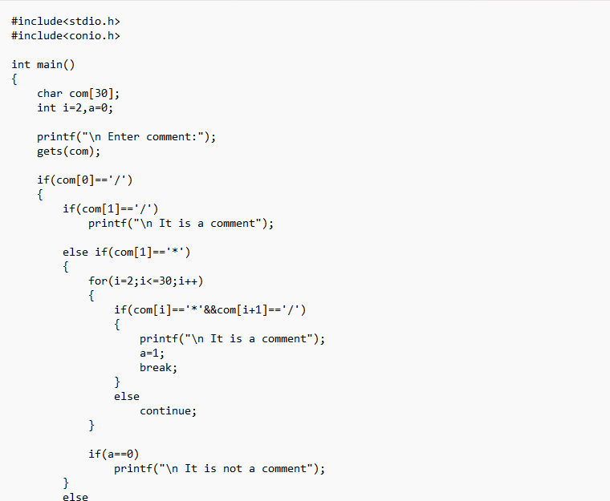
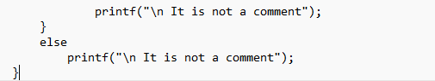
OUTPUT:-
